**Cult Anthro Unit 4 – State Formation Name ___________________________**

**What are the four basic ways of social organization? (Dummies 170-171)**  NOTES

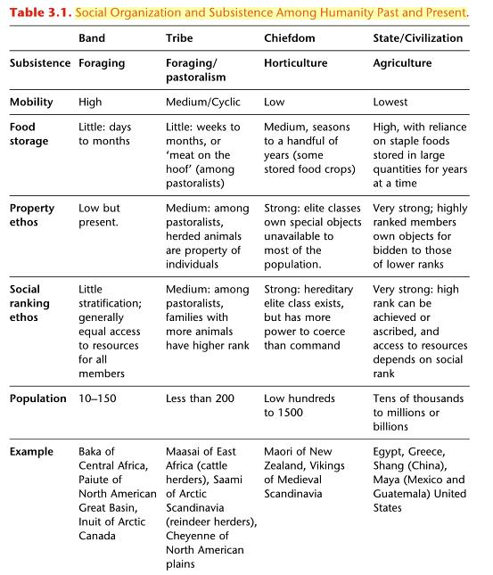

**Theories of How and Why States Form? (College 256)**

Hydraulic Systems

Long Distance Trade

Population, War, Circumscription (also define multivariate)

**What are the Characteristics / Attributions of State Civilization:**

**According to College Textbook (page 259):**

**According to Dummies Book (173-181)**

**1)**

**2)**

**3)**

**4)**

**5)**

**6)**

**7)**

**8)**

**9)**

**10)**

**11)**

**12)**

**13)**

**14)**



**Notes on Types of Societies (Lecture)**

**Egalitarian**

**Ranked**

**Stratified**

**Chiefdom**

**Primary state**

**Advanced Chiefdoms**

**A false impression box – more about Unilineal Evolution (Dummies 174)**

**Case Study in Early States (Dummies 181-185)**

**Egypt**

**Inca**

**Collapse of Civilizations (Dummies 185-186)**

**Maya Collapse (College 276-277)**